Installing Universal Forwarder on Windows Server
Splunk gets logs from remote endpoints from forwarders. In order to get these logs I must install Splunk’s Universal Forwarder.

- First I have to set up a new receiving port on the Splunk server.
- Navigate to Settings → Forwarding and Receiving → New Receiving Port
- Enter port 9997 and save
- Navigate to Settings → Indexes → New index
- Name the index “wineventlog” → save

- Now let’s install the Splunk Universal Forwarder
- 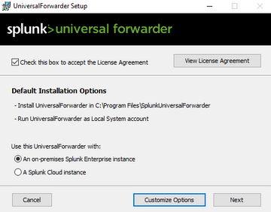
- Now I need the IP Address of the Splunk server. I can get that by switching to the Splunk instance and running the “ifconfing” commands
- 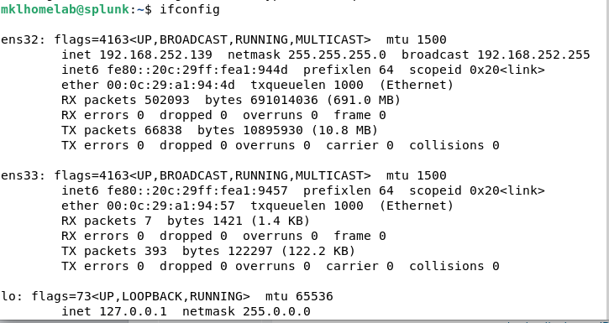
- The IP Address is 192.168.252.139
- Enter the IP Address of your Splunk server and the default ports as prompted (8089 & 9997)
- 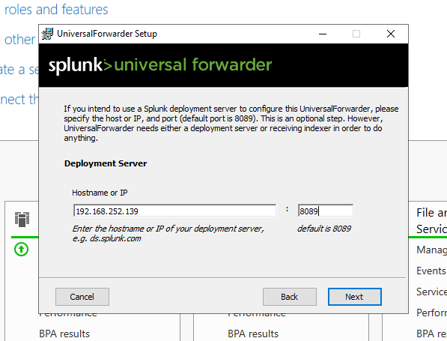
- Navigate back to your Splunk Instance → Settings → Add Data
- Select “Forward”
- I can see that the Domain Controller did connect!
- Click on the host (HOMELAB-DC) and enter the server name “Domain Controller”
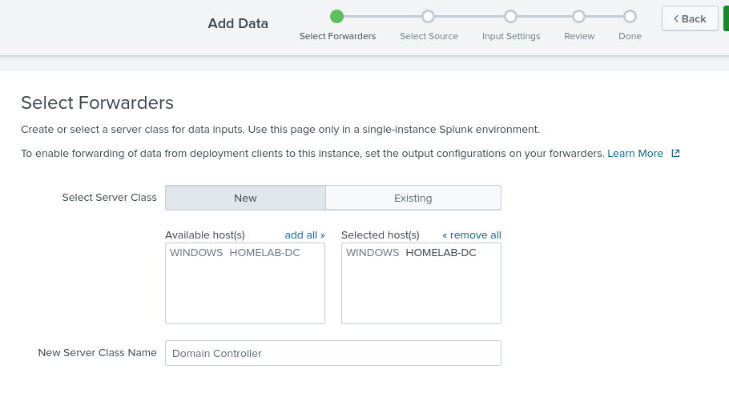
- Select Local Event Logs and “add all”. Then Click Next.
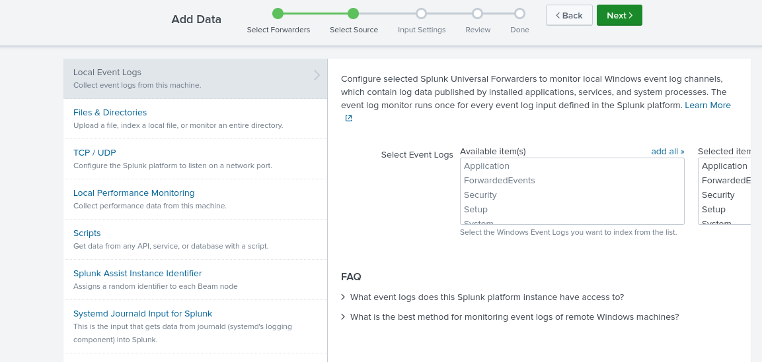
- Select “wineventlog” as the index → Review → Submit
- After it finishes click “search” and we are done!
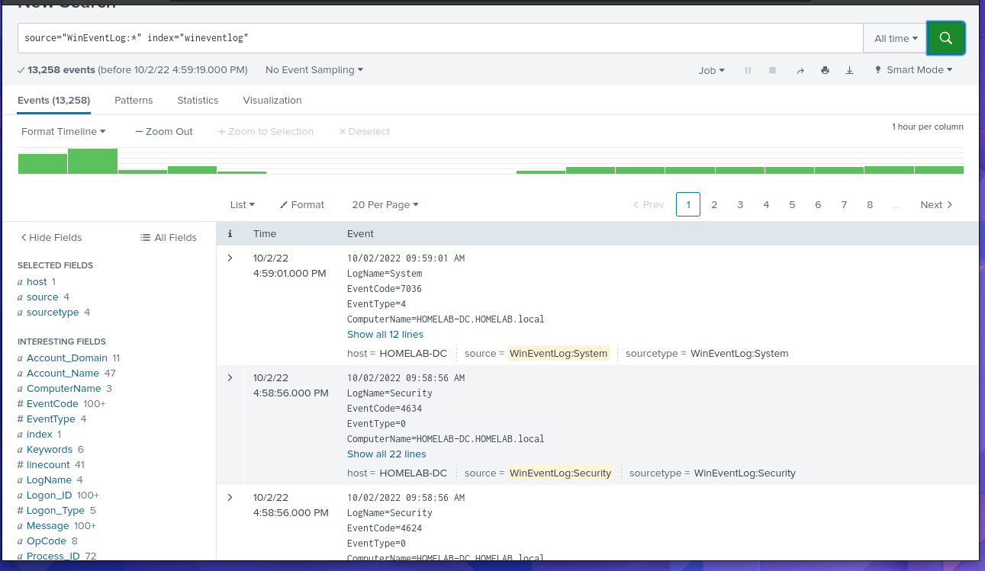

- I can now look through the interesting fields. I can look through all the details for all the logs and see exactly whats going in my system. Can’t wait to work on detection rules, SIEM content, rule tuning, and even attack scenarios!

